1: Create a PowerBI Dataset in powerBI web:

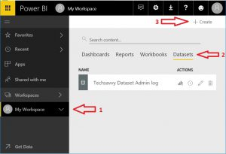

2: Assign the dataset the following tables.  
Note:

Realprocessdate = Time

Latitude & Longitude = number

All other fields = text

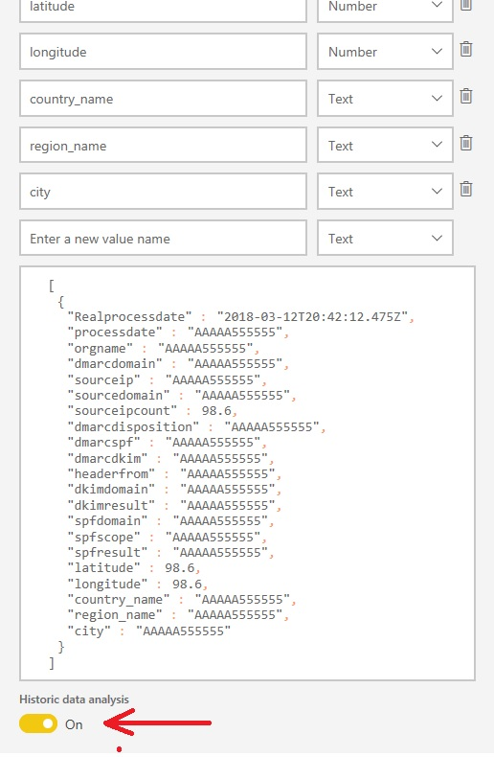

SET HISTORICAL DATA = ON !!!!

3: After creation request the information and look at the powershell code.   
copy the endpoint.

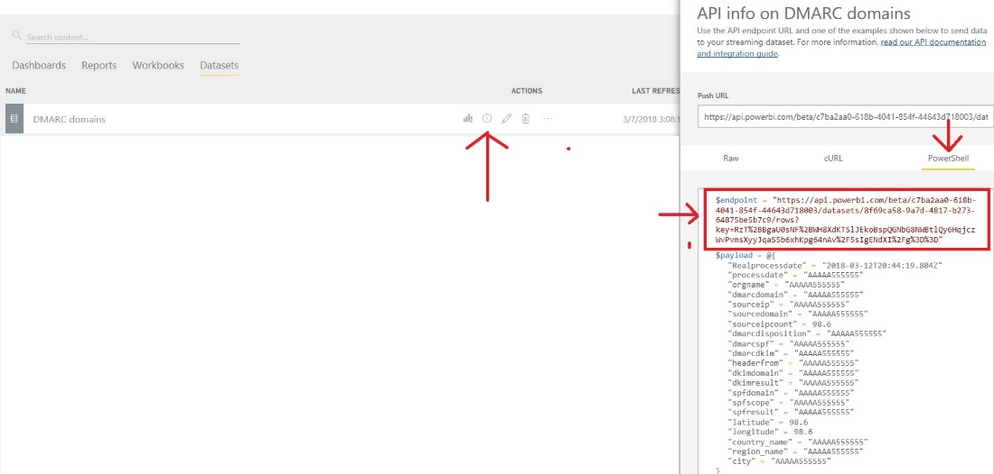

4: paste the endpoint into the script @ line 447

